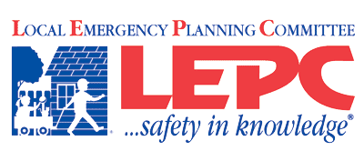
Lincoln County Kansas
__________________________________________________
Agenda
Date and Time: Monday, January 29, 2018 NOON
Lincoln County Hospital
- Roll call by sign-in
- Introduce guests
- Approval of last meeting’s minutes
- Communications –
LEPC Conf. 2018
Chamber Annual Meeting
10-33 Foundation
- Agency/individual reports
- Old Business
February 15 Mass Fatality Exercise, Salina
Final TEPW – David
- New Business
HMEP Grant – David
LEPC Bank Account – Ladonna and David
Appoint New members
Review ESF10
- Public Forum
- Adjourn

Appointed Members:
David Dohe– Emergency Management- Chair
Shawn Esterl, Environmental - Vice-Chair Steve Granzow, PIO/Media
Jeff White, Firefighting - Bret Kingan, Emergency Medical
Ladonna Reinert, Health – Secretary Jennifer O’Hare, Legal Counsel
Jon Ahlquist, Business and Industry Gary Kuehn - Law Enforcement
Terry Finch, Elected Official Scot Kerns, Community Groups
Kati Gardner, Hospital Michel O’Hare – Transportation
Invited Guests:
Randy Rathbun Kathy Robertson Jude Stecklein Richard Ubben (Tallgrass Energy)
Marc Lovin Ronald Nelson Brad Nitsch Dustin Florence
Travis Schwerdtfager Stuart Johnson(Southern Star)
Mark McMillin and Frank Georgiana (Enel EGP North America)
Deb Tucker (Red Cross) Sherry Angell

