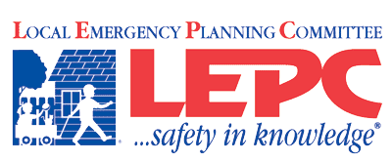
Lincoln County Kansas
__________________________________________________
Agenda
Date and Time: Monday, April 30, 2018 - NOON
Lincoln County Hospital
- Roll call by sign-in
- Introduce guests
- Approval of last meeting’s minutes
- Communications –
LEPC Conf. 2018
- Agency/individual reports
- Old Business
Red Cross MARC and Shelter training
HMEP Grant – David

- New Business
February 15 Mass Fatality Exercise, After Action Report

- Public Forum
- Adjourn

Appointed Members:
David Dohe– Emergency Management- Chair
Shawn Esterl, Environmental - Vice-Chair Steve Granzow, PIO/Media
Jeff White, Firefighting Bret Kingan, Emergency Medical
Ladonna Reinert, Health – Secretary Jennifer O’Hare, Legal Counsel
Jon Ahlquist, - Business and Industry Gary Kuehn - Law Enforcement
Terry Finch, Elected Official John Paul Ellis, Community Groups
Kati Gardner, Hospital Michel O’Hare – Transportation
Invited Guests:
Randy Rathbun Kathy Robertson Richard Ubben (Tallgrass Energy)
Marc Lovin Ronald Nelson Dustin Florence
Sherry Angell Jude Stecklein Stuart Johnson(Southern Star)
Brad Nitsch Deb Tucker (Red Cross) Travis Schwerdtfager
Mark McMillin & Frank Georgiana (Enel EGP North America)

